Emoji Design

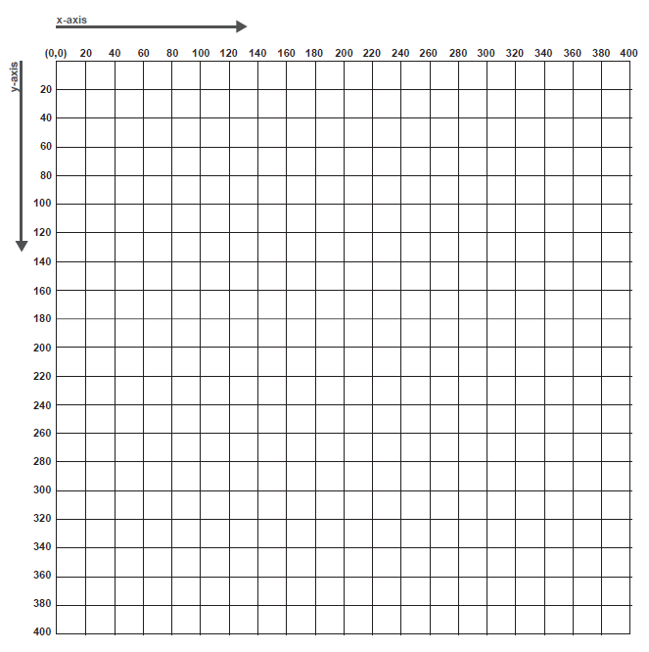

Plan

**Pseudocode**

What steps will you take to implement this idea? Be as specific as possible:

| Step 1 | Step 2 | Step 3 |
| --- | --- | --- |
| //face  strokeWeight: 5  ellipse:  x: 200  y: 240  width: 160  height: 200 | //nose  strokeWeight: 5  rect:  x: 180  y: 220  width: 20  height: 60  rect:  x: 200  y: 260  width: 20  height: 20 | //hat  strokeWeight: 5  center triangle:  x1, y1: 120, 180  x2, y2: 200, 60  x3, y3: 280, 180  left triangle:  x1, y1: 80, 120  x2, y2: 160, 120  x3, y3: 120, 180  right triangle:  x1, y1: 240, 120  x2, y2: 320, 120  x3, y3: 280, 180 |